Damping Control of Shock Absorber using Electromagnetism

ABSTRACT
A shock absorber has a piston for generating damping force in response to piston stroke in one of bounding and rebounding direction. The Liquid or Hydraulic Oil inside the Piston produces force for flow restriction and thus increasing damping force to be generated in response to the piston stroke in one of the bounding and rebounding directions.
This project will use a special type of liquid with variable frictional force based on increasing and decreasing Electromagnetism around the liquid inside the piston.

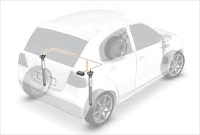

The electronic circuitry will be involved to control the electromagnetic property of liquid by changing the voltage across the coil.
The Sensor used for the purpose will be general purpose Accelerometer which can detect the change in direction and speed in X, Y or Z direction.
The reading from the accelerometer will be fed to the microcontroller unit which will decide the value of voltage to be passed to the coil in order to control the electromagnetic property of the fluid.

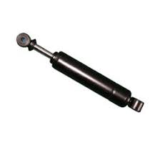
Two accelerometers will be attached to each of the parts of the piston. One at the moving shaft and other at the nonmoving end.
The distance and variation in speed of the two accelerometers will be taken as reading by the microcontroller unit (Arduino Uno with AT mega 328).

Accelerometer
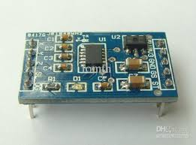
An accelerometer is a device that measures proper acceleration ("g-force"). Proper acceleration is not the same as coordinate acceleration (rate of change of velocity). For example, an accelerometer at rest on the surface of the Earth will measure an acceleration g= 9.81 m/s² straight upwards. By contrast, accelerometers in free fall orbiting and accelerating due to the gravity of Earth will measure zero.
Accelerometers have multiple applications in industry and science. Highly sensitive accelerometers are components of inertial navigation systems for aircraft and missiles. Accelerometers are used to detect and monitor vibration in rotating machinery. Accelerometers are used in tablet computers and digital cameras so that images on screens are always displayed upright. Accelerometers are used in drones for flight stabilization. Pairs of accelerometers extended over a region of space can be used to detect differences (gradients) in the proper accelerations of frames of references associated with those points. These devices are called gravity gradiometers, as they measure gradients in the gravitational field. Such pairs of accelerometers in theory may also be able to detect gravitational waves.

Block Diagram

Microcontroller Unit (Arduino Uno)
Accelerometer 1
Accelerometer 2

Control voltage for Electromagnetism

